**“(Cryptocurrency Tracker)”**

**SUBMITED BY**

1. ----------------------------------
2. -------------------------------------



**Department Of Computer Application.**

**K.K.Wagh Arts, Commerce, Science and Computer Science College.**

**Nashik-422003**

**Academic Year 2022-23**



Karmaveer Kakasaheb Wagh Education Society’s

**K. K. Wagh Arts Commerce, Science, & Computer Science College**

**Saraswati Nagar Nashik-422003**

**C E R T I F I C A T E**

This is to certify that,

**Mr**./**Miss_____________________________________________**

has satisfactory completed his/her/their project ________________________________________ as fulfillment in **T.Y.B.B.A.(Computer Application)** Class for the academic year **2022-2023**.

Project Done by: _______________________

_______________________

Prof. V.H.Bava

Project Guide

(H.O.D )

Internal Examiner External Examiner

**Index - Website Project**

| **Sr. No** | **Documentation Content** | **Page No** |
| --- | --- | --- |
| **I** | **Introduction** | |
| 1 | Motivation |  |
| 2 | Problem Statement |  |
| 3 | Purpose / Objective and Goals |  |
| 4 | Literature Survey |  |
| **II** | **System analysis** | |
| 1 | Existing Systems |  |
| 2 | Scope and Limitations of Existing Systems |  |
| 3 | Project Perspective , Features , Stakeholders |  |
| 4 | Requirement Analysis -  Functional requirements, Performance requirements,  Security requirements etc |  |
| **III** | **System Design** | |
| 1 | Class Diagram |  |
| 2 | Use Case ,Activity Diagram , Sequence Diagram , Deployment Diagram |  |
| 3 | User Interfaces |  |
| **IV** | **Implementation details** | |
| 1 | Software / Hardware Specifications |  |
| **V** | **Outputs and Reports Testing** | |
| 1 | Screenshot and Report |  |

**Index - Application Project**

| **Sr. No** | **Documentation Content** | **Page No** |
| --- | --- | --- |
| **I** | **Introduction** | |
| 1 | Motivation |  |
| 2 | Problem Statement |  |
| 3 | Purpose / Objective and Goals |  |
| 4 | Literature Survey |  |
| **II** | **System analysis** | |
| 1 | Existing Systems |  |
| 2 | Scope and Limitations of Existing Systems |  |
| 3 | Project Perspective , Features , Stakeholders |  |
| 4 | Requirement Analysis -  Functional requirements, Performance requirements,  Security requirements etc |  |
| **III** | **System Design** | |
| 1 | ERD |  |
| 2 | Data Dictionary |  |
| 3 | Use Case, Sequence, Activity, Component, Deployment Diagram |  |
| 4 | User Interfaces |  |
| **IV** | **Implementation details** | |
| 1 | Software / Hardware Specifications |  |
| **V** | **Outputs and Reports Testing** | |
| 1 | Screenshot and Report |  |

**Motivation**

We own our sincere gratitude to all those people who have given us their constant support and encouragement without which our project report would not have reached this stage.

We would like to express our thanks to Prof V.H Bava(H.O.D) and also Project Guide Prof.P.B.Chavhan and Prof. D.K.Sonwane for her advice and encouragement. She has been a pillar of strength right through the project till the preparation of this report and helped by boosting morale, so we could surmount the difficulties that came across during completion of this project.

We would like to express our gratitude to Dr. S.V. Patil , Principal, K.K.Wagh Arts, commerce, science and Computer Science College and Prof.Vijayshri Bava, Head of Computer Application department for the support and the infrastructure they have provided, so that we could successfully complete the project on time.

Last but not the least, we would like to express our sincere thanks to all staff members and our friends for their help and cooperation in all phases of the project.

1. -------------------------------------
2. -------------------------------------

Problem Statement

Along with economic benefits, any new technology also comes with a certain number of problems. Cryptocurrencies are no exception. Cryptocurrencies are basically the same as e-money — like Web Money or PayPal. That means they also have the same problems as classic e-payment systems.

However, the operating principles specific to cryptocurrencies sometimes make the problems more likely to occur, and thus more disturbing. In addition, the same principles are responsible for a certain number of risks unique to cryptocurrencies.

### **Spoofing payment information and phishing**

We’ll start with common problems such as plain old theft. Let’s say you’re transferring money to a friend. You copy his wallet address accurately, but [malware replaces the address in the clipboard with another one](https://www.kaspersky.com/blog/cryptoshuffler-bitcoin-stealer/19976/). Not every user is vigilant and double checks an address after copying it. Especially if the address is a long jumble of characters.

Or take phishing, for another example. As with ordinary e-money, users can be tricked into going to a phishing website where they upload their crypto wallets and enter a password.

### **User address error :-**

### The preceding cases were typical electronic-money issues, but as we’ve already said, cryptocurrencies add their own wrinkles. For example, there is a risk that’s very specific to cryptocurrencies — loss of money due to an error in the address to which the money transfer is made.

### **Loss of a wallet file:-**

There’s one more problem that is typical of cryptocurrencies: loss or theft of a wallet. Most users store their cryptocurrency wallet files on their computers. Therefore, they can be [stolen using malware](http://www.zdnet.com/article/now-cerber-ransomware-wants-to-steal-your-bitcoin-wallets-and-passwords-too/) or lost if the hard disk crashes.

### **Spoofing a user address:-**

Sometimes, a money-grabbing scheme is even simpler. Collection of funds in an ICO usually opens at a specified time and closes when the required amount has been collected. The collection address is posted on the project website when it opens (it’s not necessary, just common practice).

**Objective and Goals**

How can you avoid the abovementioned problems? We have several tips to help.

1. Always verify a Web wallet’s address, and don’t follow links to an Internet bank or Web wallet.
2. Before sending, double-check the recipient’s address (at least check the first and last characters), the amount being sent, and the size of the associated fee.
3. Write down a mnemonic phrase that allows you to recover a crypto wallet if you lose it or forget your password.
4. Keep a cool head and make informed decisions when crypto-investing, and don’t panic or hurry.
5. Always remember that crypto-investment is very risky. Do not invest more than you’re ready to lose at any moment. Diversify your investments.
6. Run high-quality antivirus protection to protect the devices you use to access crypto wallets, trade on crypto-exchanges, and so on.

Literature Survey

The literature is organised according to six distinct aspects of cryptocurrency trading:

* Cryptocurrency trading software systems (i.e., real-time trading systems, turtle trading systems, arbitrage trading systems);
* Systematic trading including technical analysis, pairs trading and other systematic trading methods;
* Emergent trading technologies including econometric methods, machine learning technology and other emergent trading methods;
* Portfolio and cryptocurrency assets including research among cryptocurrency co-movements and crypto-asset portfolio research;
* Market condition research including bubbles (Flood et al. [1986](https://jfin-swufe.springeropen.com/articles/10.1186/s40854-021-00321-6#ref-CR119)) or crash analysis and extreme conditions;
* Other Miscellaneous cryptocurrency trading research.

Existing System

* Low Transaction speed
* High Transaction costs
* Accessibility
* Low Security
* Low Privacy
* Low Transparency
* Diversification
* Low Inflation protection

**Scope and Limitations of Existing Systems**

**Scope**:- A cryptocurrency is a virtual currency which is based on blockchain technology. This type of currency works on cryptography. It is decentralised meaning that no authority is there behind it to regulate and control it.  
  
The number of types of cryptocurrency is increasing on a regular basis. There are over 4000 cryptocurrencies as of early 2021 but it is believed that top 20 cryptocurrencies hold the market share up to 90%.[1] Earlier people used to invest in gold as an asset to protect their money against inflation. Over the past couple of years, more people found Bitcoin to be a better alternative asset. Even institutional investors are converting their cash into Bitcoin to protect their finances against inflation.

**Limitation :-**

* Understanding cryptocurrency takes time and effort.
* Cryptocurrencies can be an extremely volatile investment.
* Cryptocurrencies haven't proven themselves as a long-term investment—yet.
* Crypto has serious scalability issues.
* Crypto newbies are vulnerable to security risks.

Project Perspective , Features , Stakeholders :-

Cryptocurrencies are a better mode of transaction for small countries where a robust banking system is yet to be developed, provided they can create the necessary mechanisms to prevent misuse. However, developed nations and countries with large populations must first try to prevent the misuse of cryptocurrencies.

**Features:-**

* Anonymity. Transactions are tied to a random sequence of characters and not to the owners identity, including personal or company data. ...
* No intermediary or supervisory bodies. ...
* Security. ...
* No centralization. ...
* Sending cryptocurrencies. ...
* Irreversable transactions. ...
* Fast development.

**Stakeholder :-**

* Cryptocurrency end-users
* Investors
* Developers
* Market enablers
* Researcher
* Financial regulatory agents

**Requirement Analysis -**

* User Action On Website
* Admin Console
* User Checked and Payment
* Mailers
* Reports

**Functional Requirement –**

* Live prices
* Fast transaction
* Security
* Live tracking of various cryptocurrencies
* Currency exchanger
* Currency converter
* Reliable
* Easy to use
* Attractive user interfaced

Performance Requirement –

* Fast, stable & secure web hosting. ...
* Highly-responsive mobile site. ...
* User-friendly web design. ...
* Robust operation systems. ...
* Fast checkout process. ...
* Transparent brand information pages. ...
* SEO-friendly web pages. ...
* Smooth sales channels integration.

**Security Requirement –**

* Use HTTPS
* SSL certification
* Monitor your website
* Scan for malware
* Ask for CVV
* Implement strong, unique passwords — and help make sure your customers do, too.
* Protect your devices.
* Steel against social engineering attempts.
* Implement additional authentication factors.
* Only store the customer data that you need.
* Make sure your site is always up to date.

**Software / Hardware Specifications**

* CPU: for web 1,6 GHz , for web and database 4 x 1,6 GHz CPU.
* RAM: 4GB.
* Minimum database space: 10GB.
* CPU: Quad 2GHz+ CPU.
* RAM: 6GB.
* Minimum database space: 10GB.

**Screenshot and Report –**

Home page :-

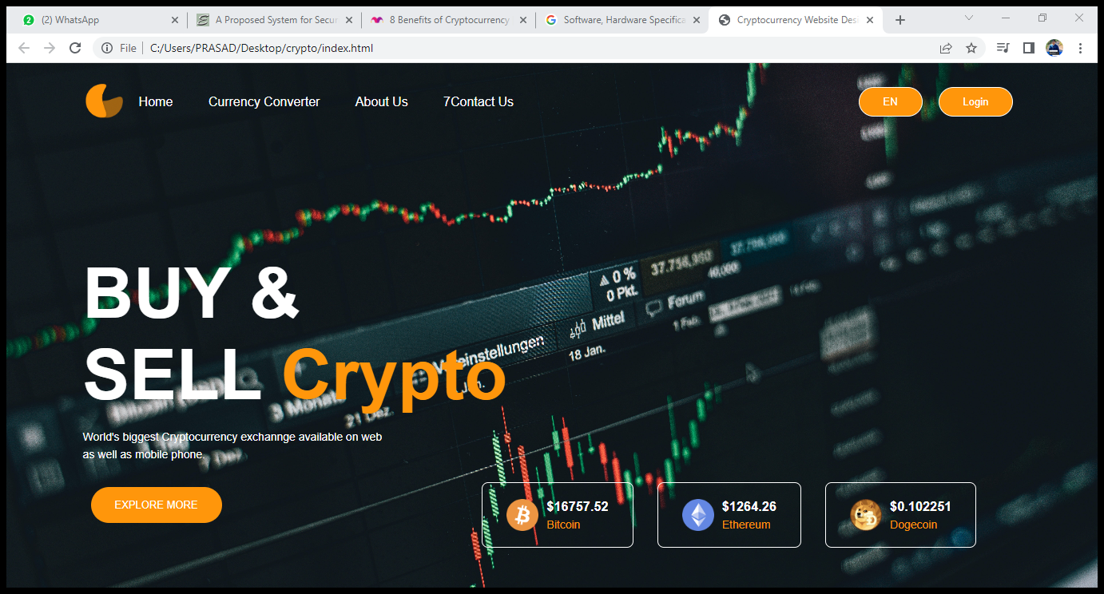

**Currency converter :-**

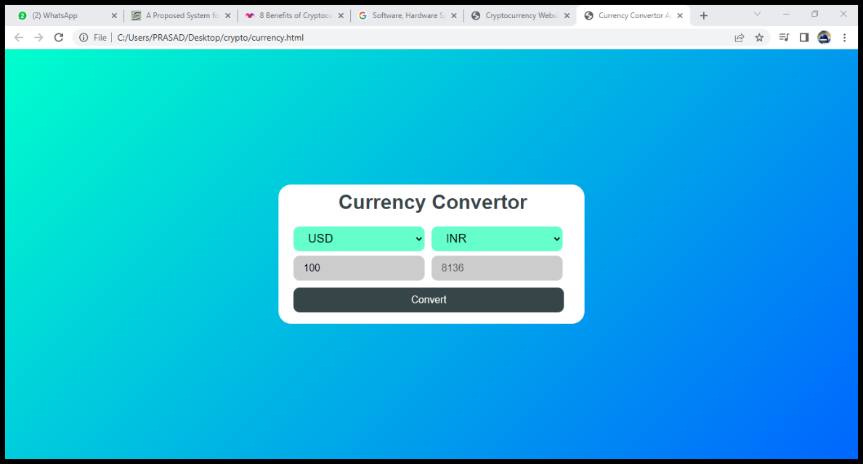

**About us :-**

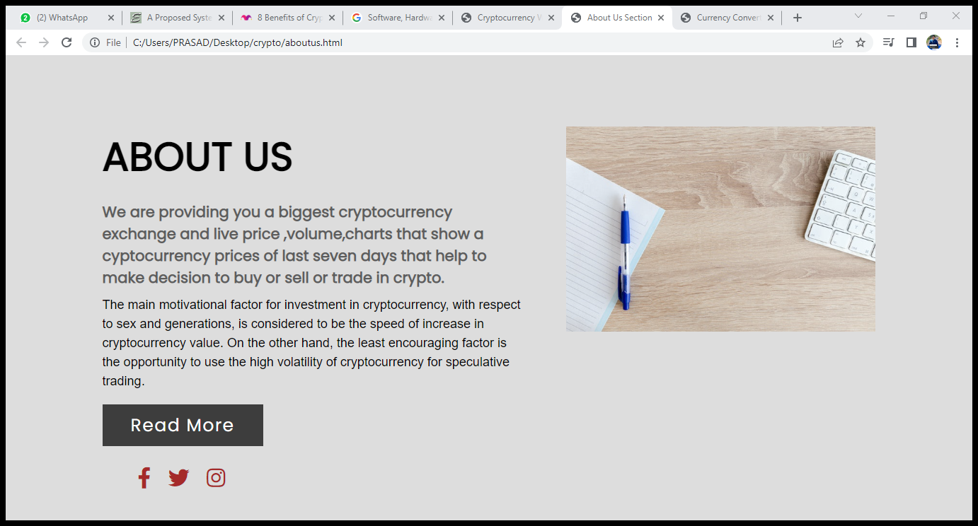

**Contact us :-**

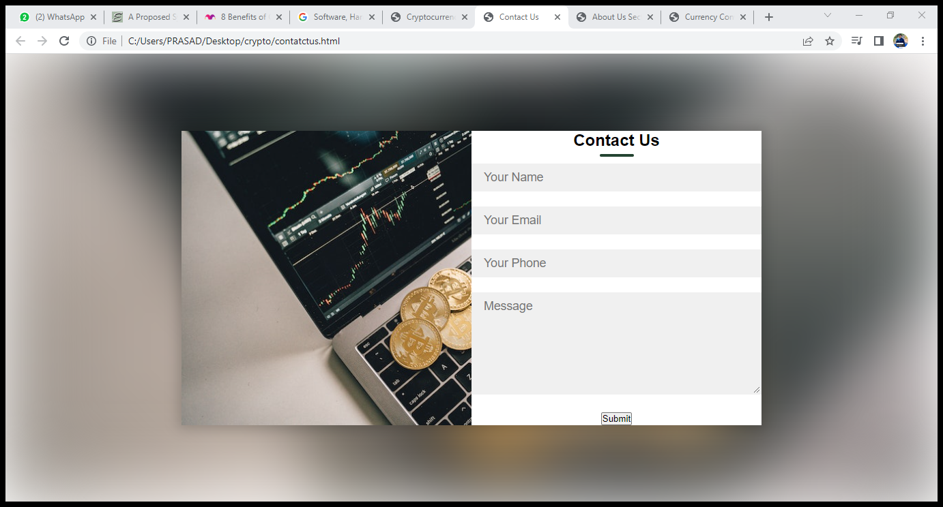

**Login page:-**

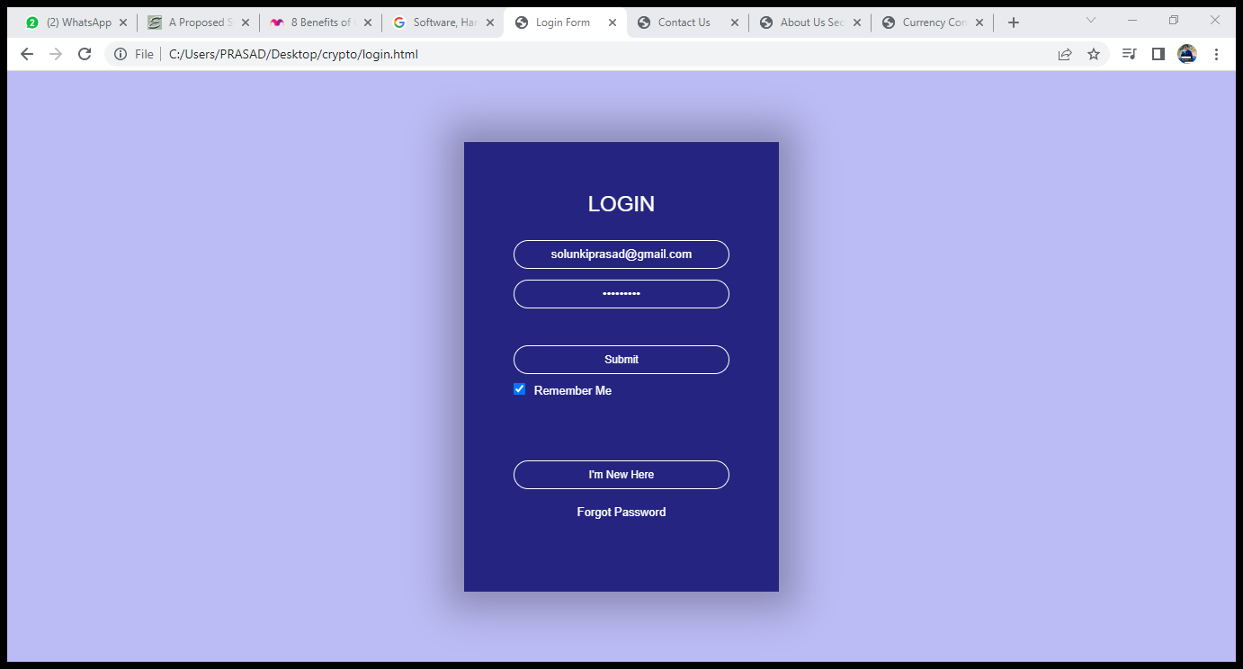

**Explore more:-**

